2020 Supply list for Visual Art I
Hello Parents,
I tried to be as reasonable as possible with what will need to be purchased. I have included pictures of some of the items with their prices. These were found at Walmart. These supplies will be needed for both distance learners AND traditional learners.
**If traditional: students will be responsible for bringing to class the needed supplies, and all supplies will be kept in their backpack. There will be NO sharing or storage in the classroom this year.
1. 10 pack of pencils |  | $0.57 | 7. pair of scissors | $1.34 | 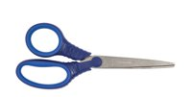
2. 18” aluminum ruler | 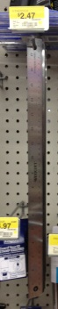 | $2.47 | 8. 4 full sheets of full posterboard  large (22x28) | $0.97/ea
3. 24 pack of crayons | 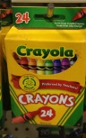 | $1.37 | 9. Triangle handled paintbrushes  (or other plastic handled) | $2.97 | 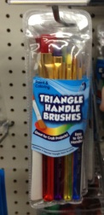
4. 3 pack of white erasers | 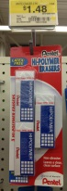 | $1.48 | 10. 2 oz. bottles of acrylic paint in  cobalt blue, bright red, yellow, black,  and white | $0.57/ea | 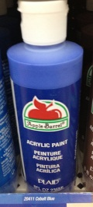
5. 10 pack of markers | 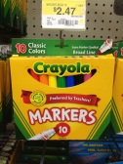 | $2.47 | 11. 36 count colored pencils | $4.97 | 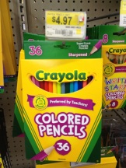
6. 3 pack of glue sticks | 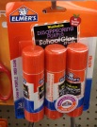 | $2.94 | 12. pencil sharpener | $0.18 | 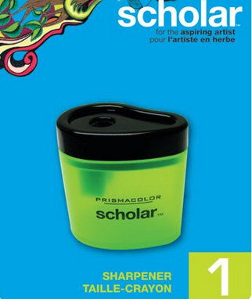

** From the Dollar Store: Watercolor paints, Pack of Styrofoam plates, plastic cups, roll of paper towels, hand soap, and Hand Sanitizer (hand sanitizer and soap to be kept in classroom; student should keep 6-7 paper towels in a ziplock in their backpack)

